Title of my paper for this conference is very interesting to attract a large audience

Abstract

We are looking forward to welcoming you to Vienna to join us in the CIE’s Midterm Meeting (CIE 2025). For CIE 2025, you are requested to submit Short Paper. The title shall be entered in UPPERCASE. Do not use quotation marks to surround the title. The title should clearly indicate the nature of the investigation. Abbreviations should be avoided in the title. Authors shall provide information on author, co-authors, presenter, author affiliation, contact email ID, etc. in the submission system so that the Short Paper organizer can avoid conflicts of interest during reviewer assignment. Abstract booklet with all accepted Short Papers will be published online. So, please write the names of all authors and their institutional affiliations in your 150-word short abstract. The author names shall have the following style: family name, initial(s) of the first name(s), e.g. Smith, M.D. The name of the presenter shall be made bold.

*Keywords*: e.g. Photometry, Colour Rendering, …

# Introduction

This and the following sections and sub-sections shall serve as an example how to structure a Short Paper. See example references below. Please submit this Short Paper as PDF as well as Word file. Your paper file for submission shall be labelled as follows: *First author's last name, first name* (serial number if more than one submission of the same author).doc(x) and *First author's last name, first name* (serial number if more than one submission of the same author).pdf. For example, when an author named David Smith (last name) submits two papers: Smith_David_01.docx, Smith_David_02.docx.

For an efficient and quicker review, Short Papers are expected to be 2-3 pages in length, including an abstract of 150 words, references, tables, and figures. The maximum allowed length is 4 pages or 1,800 words. All submissions must adhere to the guidelines described here and use the CIE template.

# Title of this clause

Section 2 is, as an example, subdivided in several subsections. This and the following sections and sub-sections shall serve as an example how to structure a Short Paper.

## Title of this subclause

Example for a figure:

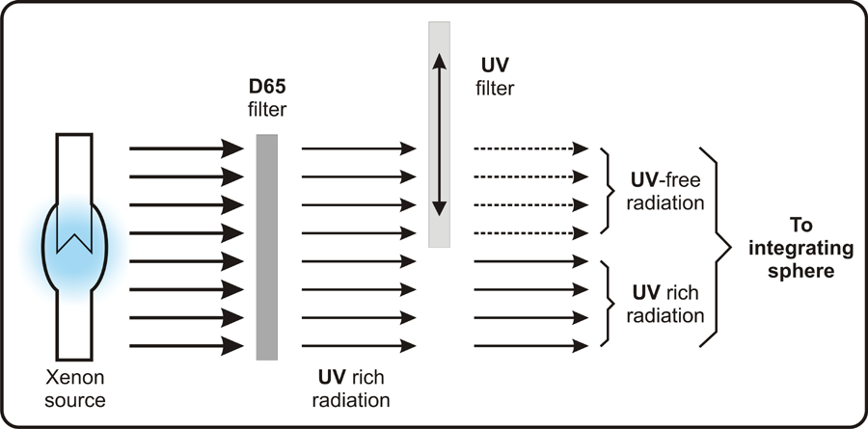

Figure 1 – Caption of Figure 1

## Section 2.2

Example for a table:

Table 1 – Caption of Table 1

|  |  |  |  |  |
| --- | --- | --- | --- | --- |
|  | ISO 3664* | ASTM D1729* | JIS Z 8717** | BS 950 |
| UV range | 0,44 | 0,44 | 1,09 | Within ±30 % |
| Visible range | 0,29 | 0,29 | 1,47 | Within ±15 % |
| Classification | Approved | Approved | Approved | Approved |

## Section 2.3

For listings use the following style:

* List item 1
* List item 2
* ……

…..

NOTE This is a note.

## Subsection 2.4

Subsection 2.4 is, as an example, subdivided in further subsections.

### Subsection 2.4.1

Text of Subsection 2.4.1.

### Subsection 2.4.2

Text of Subsection 2.4.2.

# Section 3

Text of Section 3.

Example for an equation:

 (1)

where

v is the speed of a point in uniform motion;

l is the distance travelled;

t is the duration.

References

ADRIAN, W. 1989. Visibility of Targets: Model for Calculation. *Lighting Res. Technol.*, 21, 181-188. https://doi.org/10.1177/096032718902100404

BOYCE, P.R. 2003. *Human Factors in Lighting, 2nd Ed.* New York: Taylor and Francis.

CIE 2010. CIE 191:2010. *Recommended System for Mesopic Photometry Based on Visual Performance*. Vienna: CIE.

American Optometry Association 2023. Computer vision syndrome. [Online]. [Accessed 27 April 2023]. Available from: https://www.aoa.org/healthy-eyes/eye-and-vision-conditions/computer-vision-syndrome?sso=y

IVANOVICI, M. and RICHARD, N. 2016. Entropy Versus Fractal Complexity for Computer Generated Colour Fractal Images. In: *Proceedings of the* *4th CIE Expert Symposium on Colour and Visual Appearance*, *6 - 7 September, 2016, Prague, Czech Republic*. Vienna: CIE, 432–437.

CURCIO, C.A., MILLICAN, C.L., ALLEN, K.A. and KALINA, R.E. 1993. Aging of the Human Photoreceptor Mosaic: Evidence for Selective Vulnerability of Rods in Central Retina. Investigative Ophthalmology & Visual Science, 34(12), 3278-3296.